3. Create a RSA key pair using a 4096-bit key. Attach your public-key and a screenshot of the command you executed as answer.

Execute following command to create private key and enter pass phrase for private.pem.
openssl genrsa -des3 -out private.pem 4096
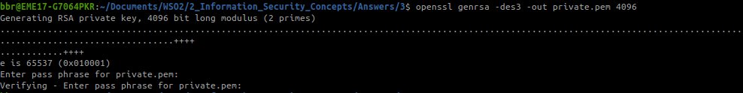
Execute following command to create public key and enter pass phrase of private key.
openssl rsa -in private.pem -outform PEM -pubout -out public.pem

